A Step-By-Step Guide to Implement AWS CI/CD Pipleline
Lets now build a CI/CD Pipeline with AWS by detailing step by step as follows:
Step 1: Create IAM Role for EC2 and AWS CodeDeploy
- Navigate to IAM service.
- Then go to roles and create a new role.
- Select trusted entity type as AWS Service and use case as EC2
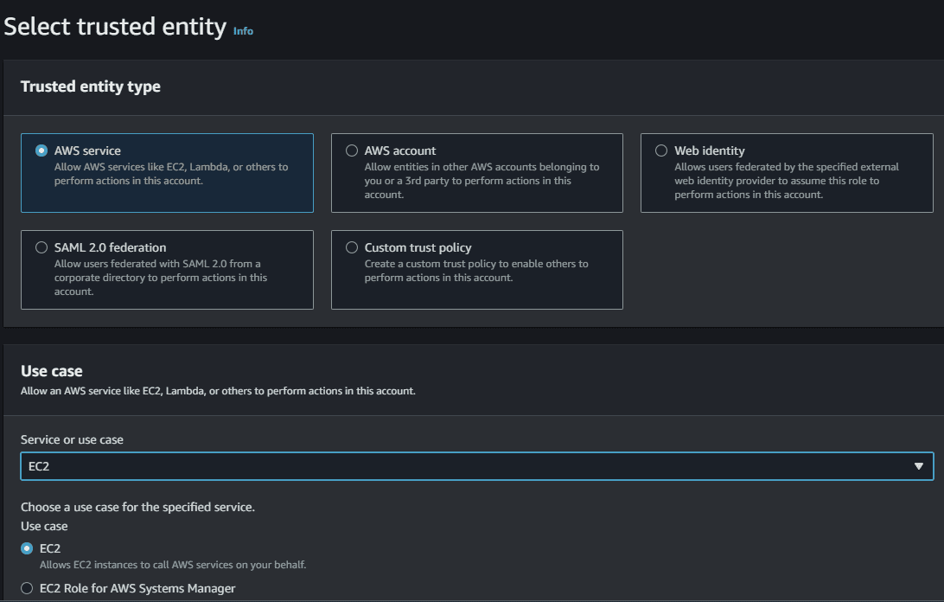
Step 2: Add permissions To IAM Role
- Select AmazonS3ReadOnlyAccess permission. It will allow our EC2 instance to access stored artifacts from the Amazon S3 bucket.
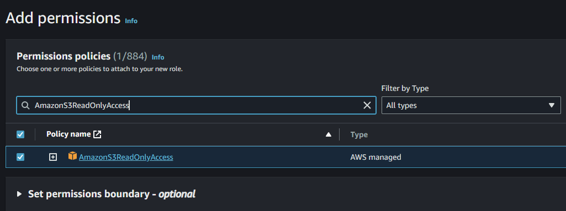
Step 3: Creating The Role For AWS CodeDeploy
- Provide the Name, review and Click on Create for creating the Role.
- Select an appropriate role name and click on create role.
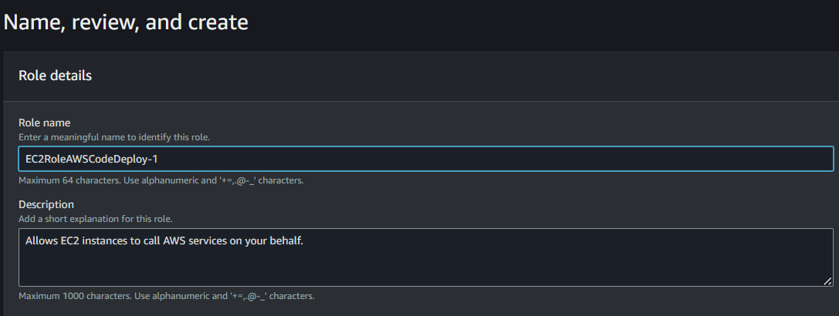
Step 4: Creating New Service Role For CodeDeploy
- Create a new service role for CodeDeploy and attach AWSCodeDeployRole policy which will provide the permissions for our service role to read tags of our EC2 instance, publish information to Amazon SNS topics and much more task.
- Repeat the Above 3 steps again with trusted entity type AWS Service, use case CodeDeploy.
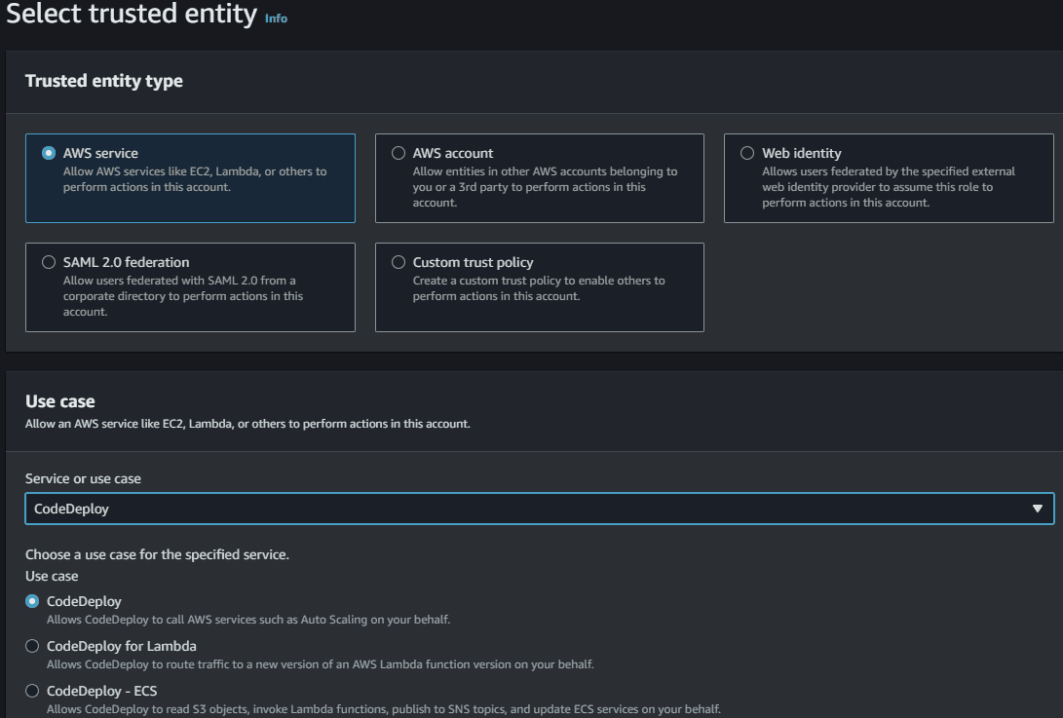
- Add AWSCodeDeployRole permissions to this creating Role
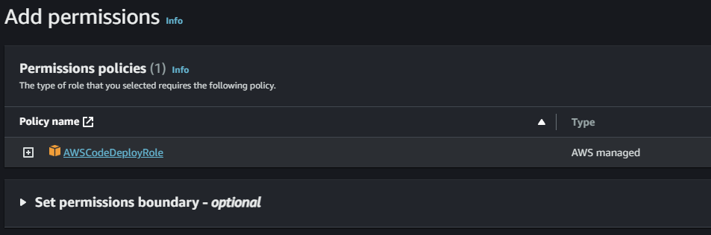
- Provide the Name, review and create the role.
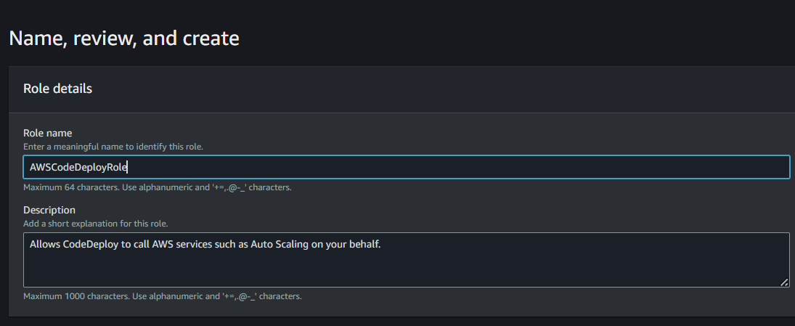
Step 5: Launch An Linux EC2 instance
- Select the instance with AMI such as "Amazon Linux" and connect to CLI Console.
- Switch to root user from ec2-user to gain admin access power by using following command "sudo su" in Linux.
sudo su
Step 6: Update The Packages
- The command "sudo yum update" is used in Amazon Linux, CentOS, and Red Hat Linux distributions to update installed packages on your system to their latest available versions.
sudo yum update
Step 7: Install The Ruby And Wget Software
- The command 'sudo yum install ruby' is used to install the Ruby programming software using the YUM package manager.
sudo yum install ruby
- The command sudo yum install wget is used to install the "wget" package on a system running Amazon Linux, CentOS, or other Red Hat-based Linux distributions that use the YUM package manager.
sudo yum install wget
Step 8: Download CodeDeploy Agent Script
- Downloading the AWS CodeDeploy agent installation script from the AWS S3 bucket is an essential step in setting up AWS CodeDeploy for your infrastructure.
- The CodeDeploy agent is a lightweight, scalable software component that enables AWS CodeDeploy to deploy and manage applications on your EC2 instances or on-premises servers.
wget https://aws-codedeploy-us-east-1.s3.amazonaws.com/latest/install
Step 9: Run Installation Script
- The command chmod +x ./install is used to make a file executable in a Unix-like operating system, including Linux.
chmod +x ./install
The command 'sudo ./install auto' is likely used to run an installation script with superuser (administrator) privileges and pass the "auto" argument to the script.
sudo ./install auto
Step 10: Check CodeDeploy Agent Status
- The command sudo service codedeploy-agent status is used to check the status of the AWS CodeDeploy agent running on your system.
sudo service codedeploy-agent status
Step 11: Modifying IAM Role
- After running the following commands, select the instance and click on "Actions", then click on "Security" and click on "Modify IAM Role". Then choose the above created IAM Role and click on "Update IAM Role".
- After this step, your EC2 instance gets attached with your above created IAM Role.
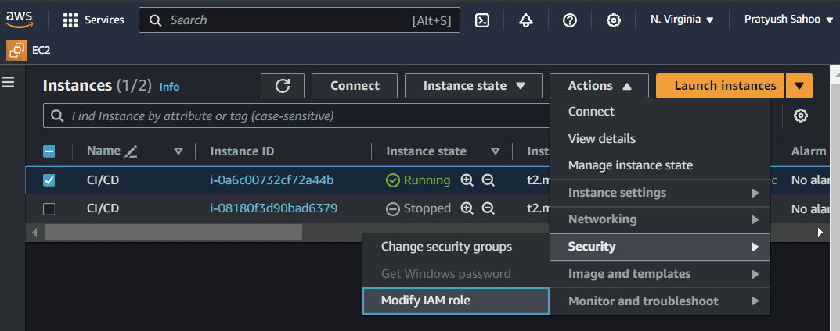
- Modify the IAM role by clicking on the button Update IAM role as shown in the figure.
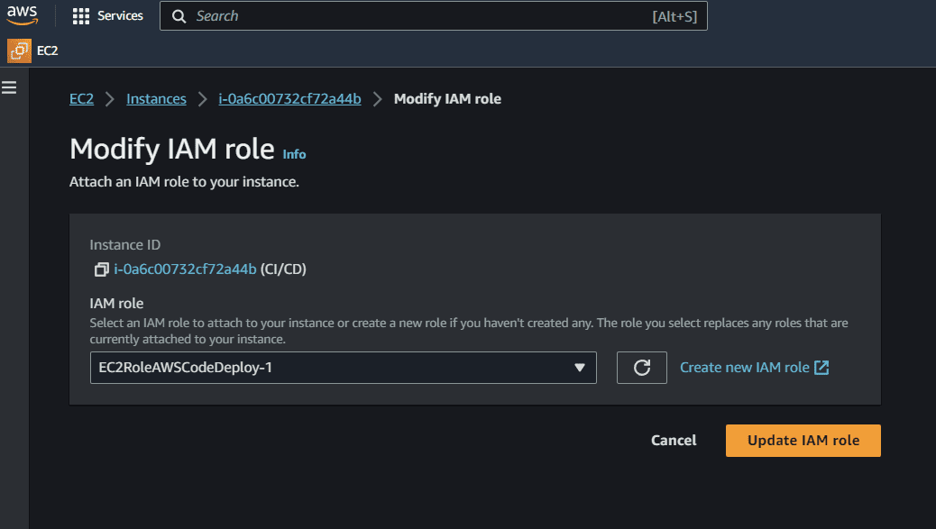
Step 12: Finalizing The Configuration
After this process, go to the console where your instance is connected and run the command "exit" to exit from the root folder and go back to the EC2 folder. Make a directory on the EC2 folder named "server", this is the directory where my source code will be deployed.
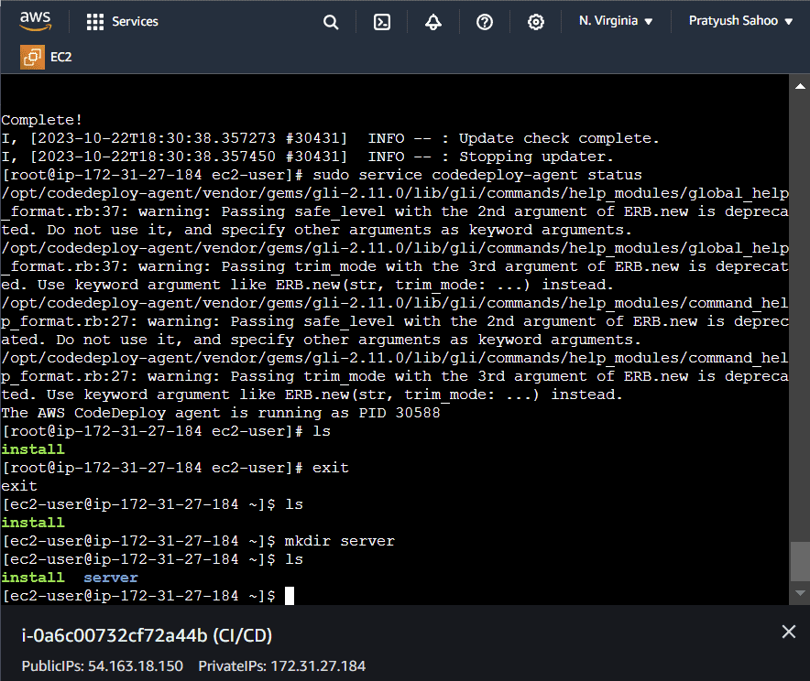
- Then after doing the above process, come back to the running instances list.
- Select your currently created running instance and go to the "Security" section present at the end of the page.
- Click on the link present under the "Security Groups". After redirecting to the required page, click on "Edit Inbound rules" under the section of "Inbound rules" present at the end of the page.
- Then add a rule, select a port range of your choice and select the source as "Anywhere-IPv4" from the dropdown menu and then click on "Save rules".
- Basically, let me give you a overview what we are actually doing here. In brief, when you add an inbound rule to a security group for an instance with port range (in my case, it was 4000) and set the source to "Anywhere-IPv4," you are allowing any computer or device on the internet to connect to your instance through port 4000.
- This is like opening a door (port 4000) on your server and letting anyone from anywhere access the service or application running on that port.
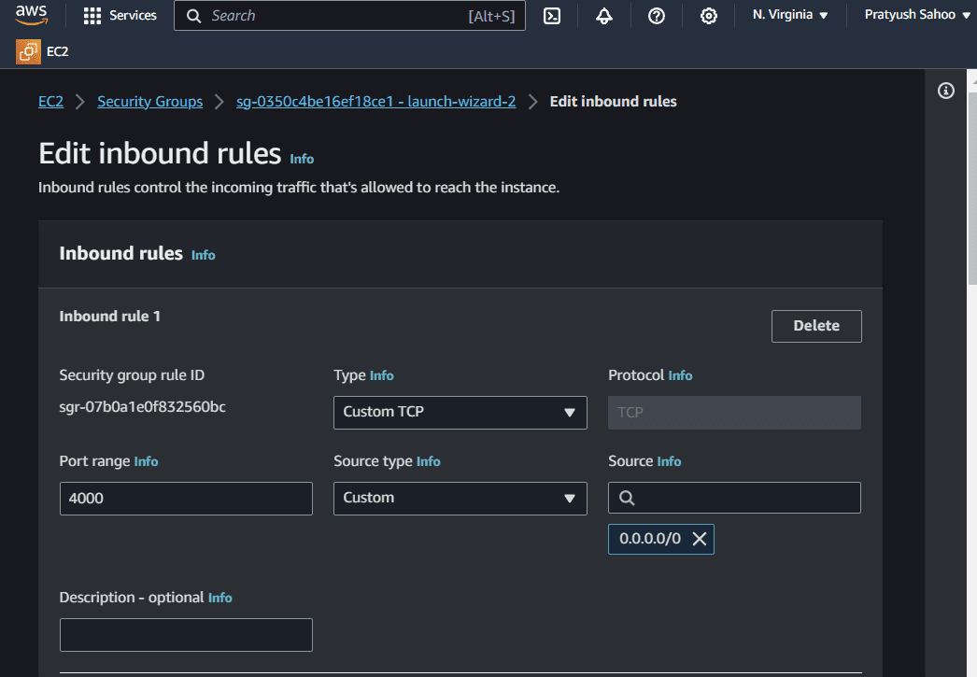
Step 13: Create A New Pipeline
- Create a CodePipeline using Github, CodeBuild and CodeDeploy
- Firstly Create CodePipeline navigate to CodePipeline via AWS Management Console and click on Create pipeline.
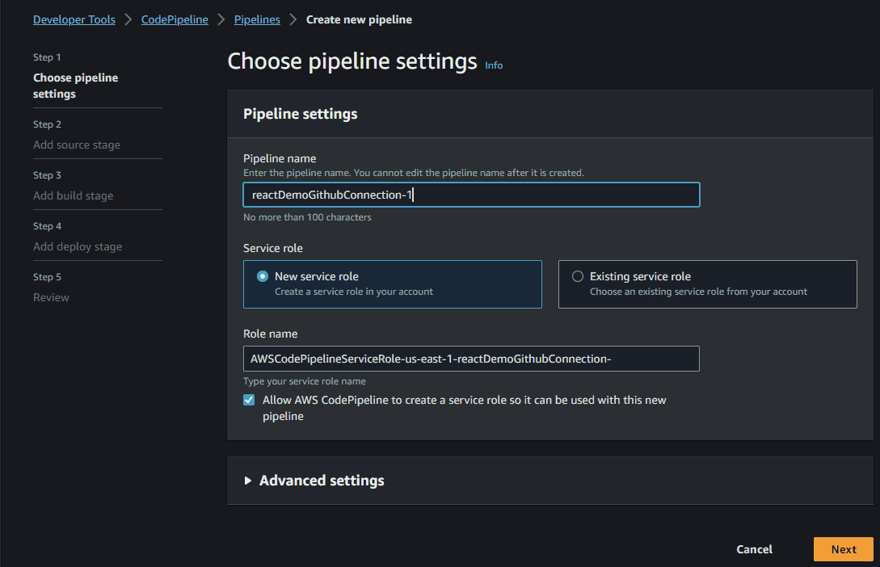
Step 14: Choose Github In Code Source
- After selecting GitHub as the source provider, click on the Connect to GitHub button. You’ll then be prompt to enter your GitHub login credentials.
- Once you grant AWS CodePipeline access to your GitHub repository, you can select a repository and branch for CodePipeline to upload commits to this repository to your pipeline.
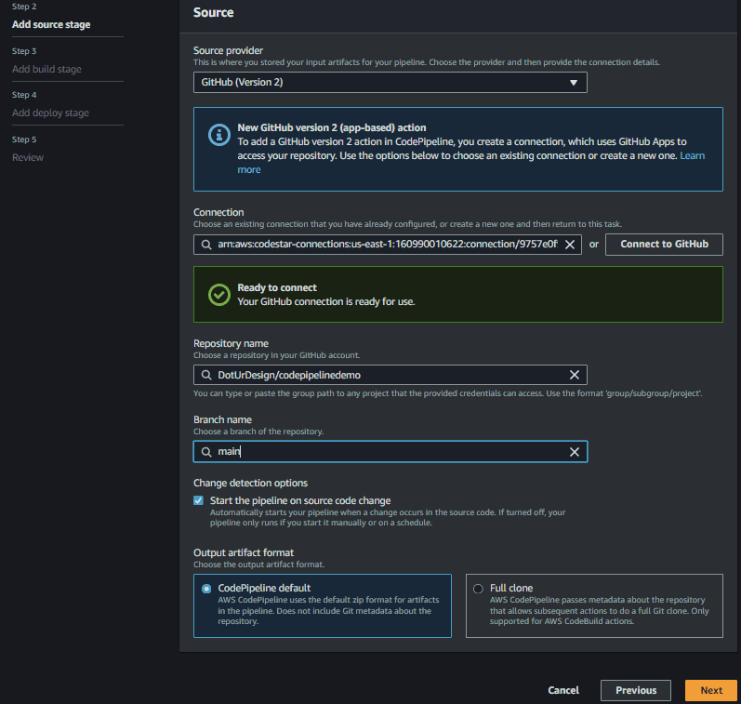
Step 15: Configure CodeBuild (Optional)
- If you haven’t created a project prior to creating your pipeline, then you can create a project directly from here by clicking Create project button.
- Note: Buildspec file is a collection of build commands and related settings, in YAML format, that CodeBuild uses to run a build. For my project, I created a buildspec.yaml file and added it in the root of my project directory.
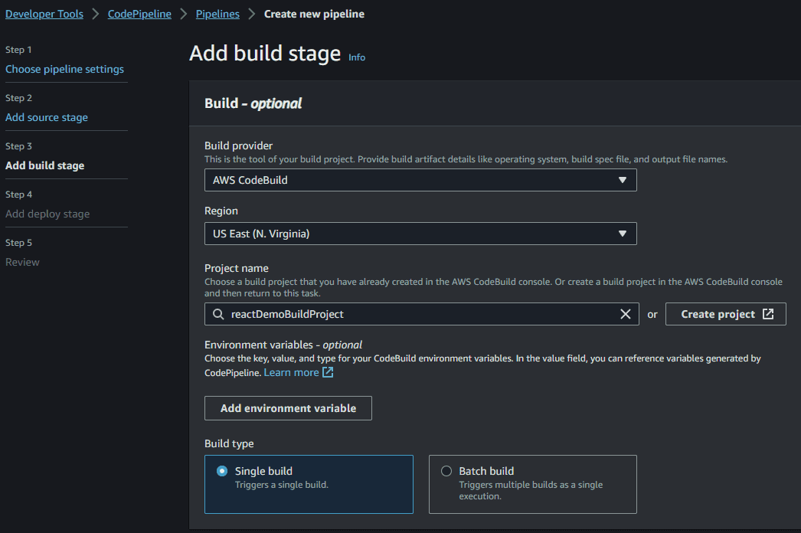
Step 16: Add Deploy Stage
Note : Before going to configure Add Deploy Stage, Let's make duplicate tab of current tab.
- Go to code deploy in the navigation, Select Application, then add create a deployment group.
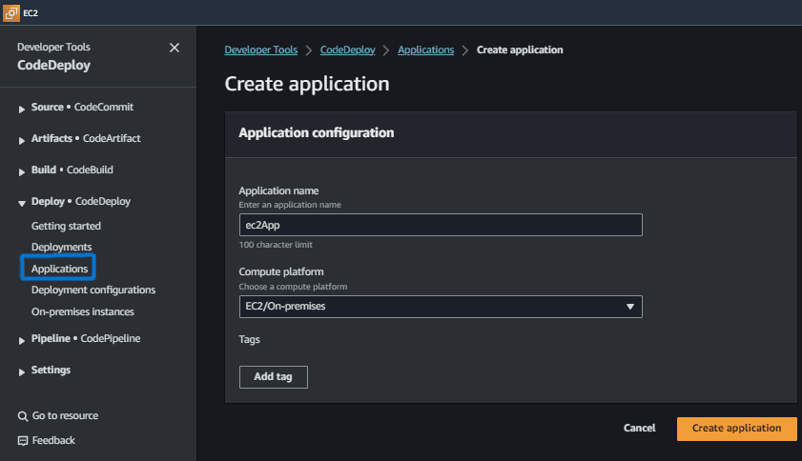
- Create a deployment Group by clicking on the button "Create deployment group", the following screenshot illustrates with practically.
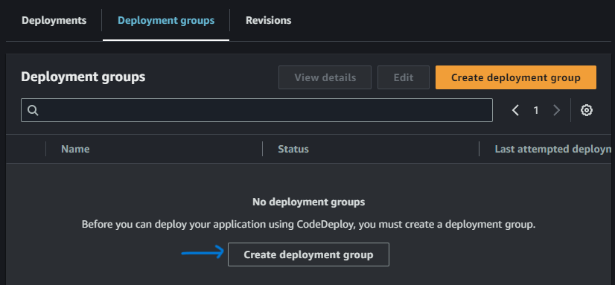
- In deployment group Select EC2 instances and select Tag and Value
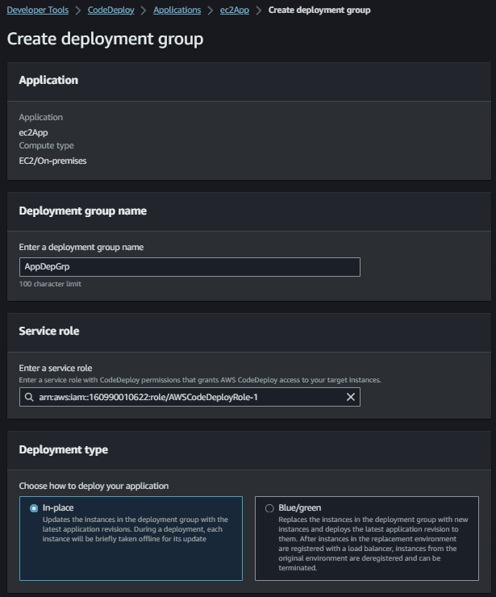
- Provide the Environment configurations such as select the Amazon EC2 Instances and provide the key and values to it.
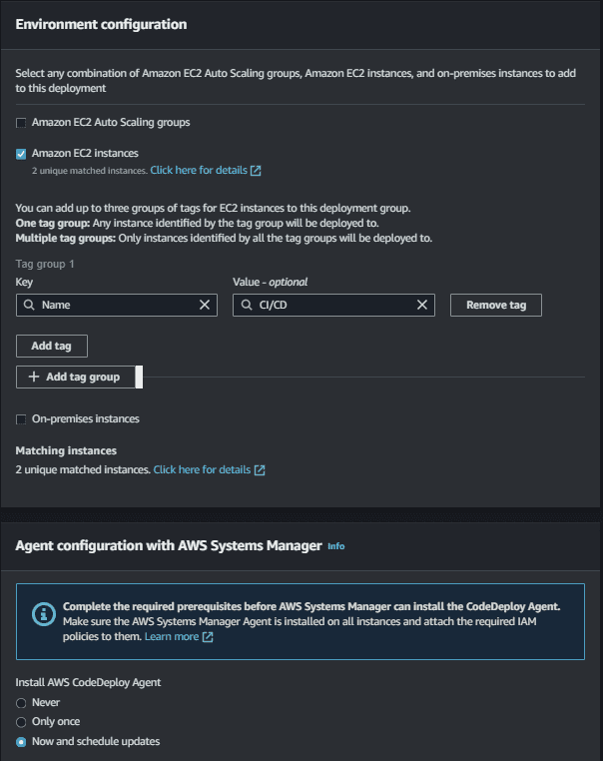
- Uncheck Load Balancer Option
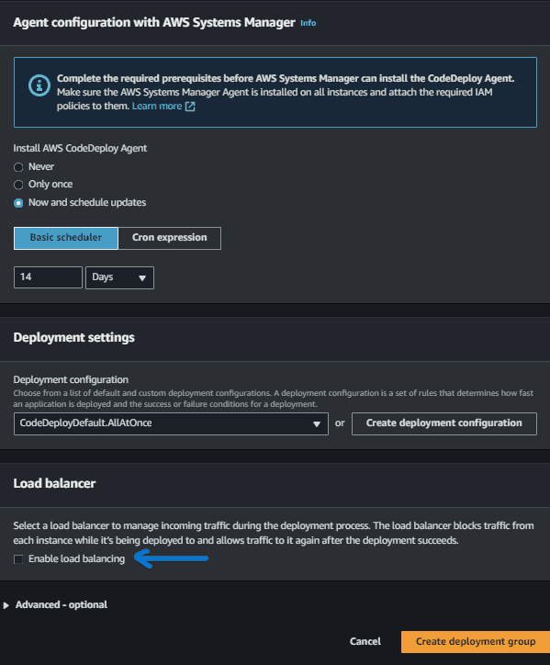
- Finally Come on Add Deploy Stage and select that created Application name and Deployment group
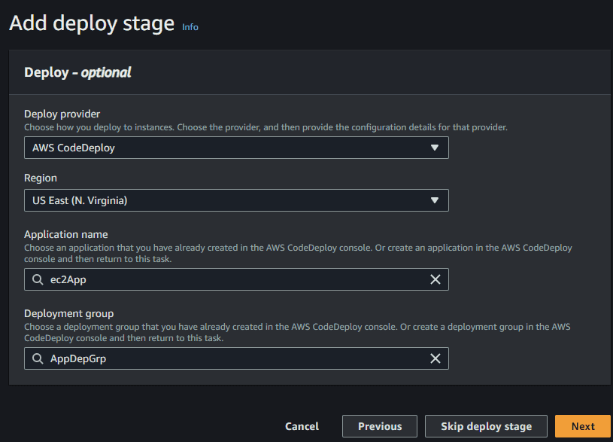
Step 17: Review And Create
- As a final step review and create it. By creating this we have successful the created a CI/CD pipeline in AWS.
